Flow 1: Consent Generation
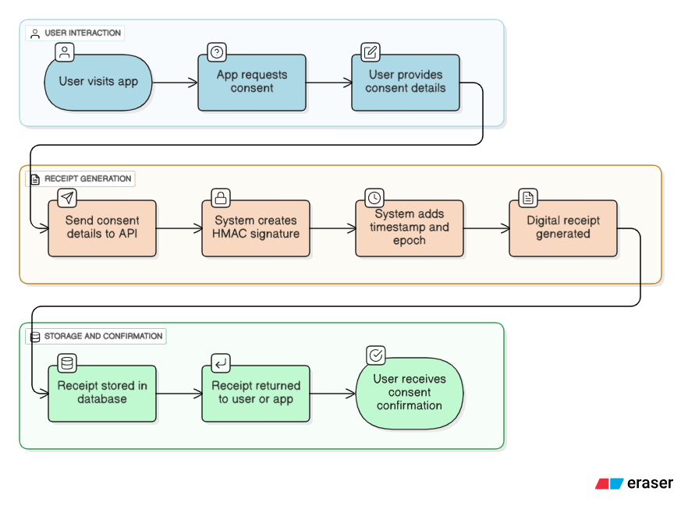

Flow 2: Real-time Verification
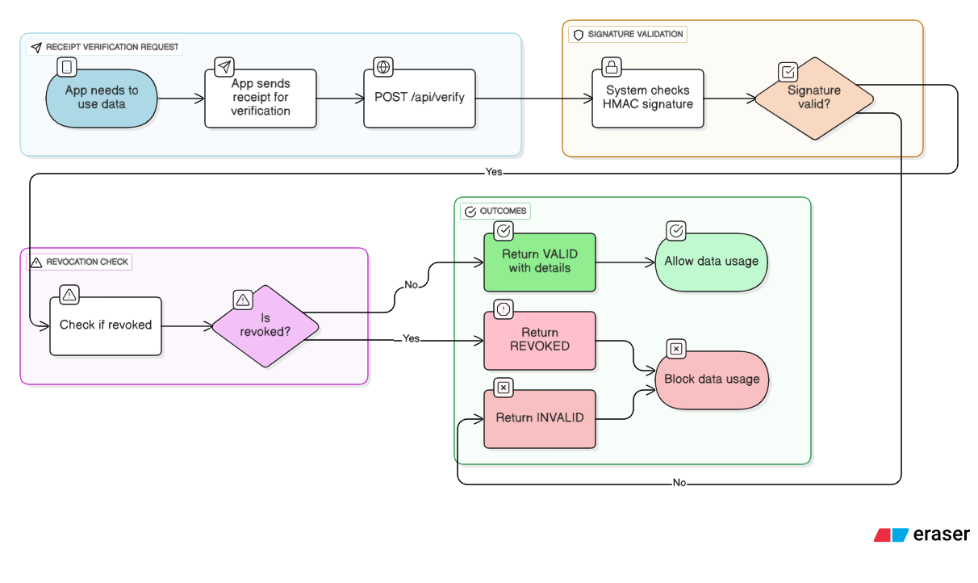

Flow 3: Revocation Control

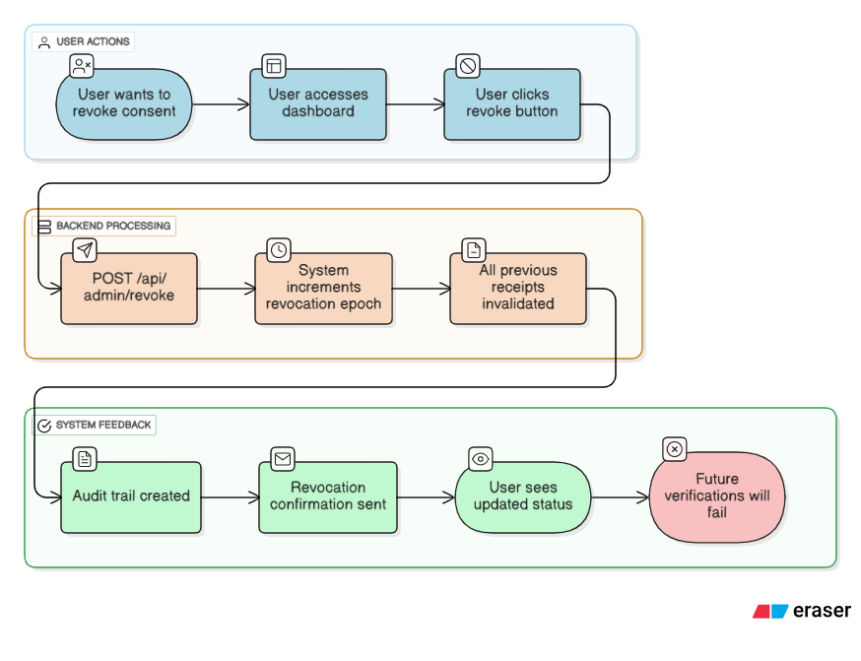

Flow 4: Usage Beaconing
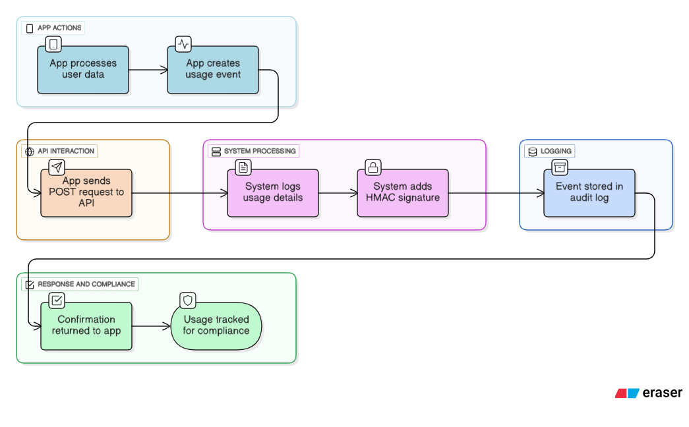

Flow 5: Dashboard View
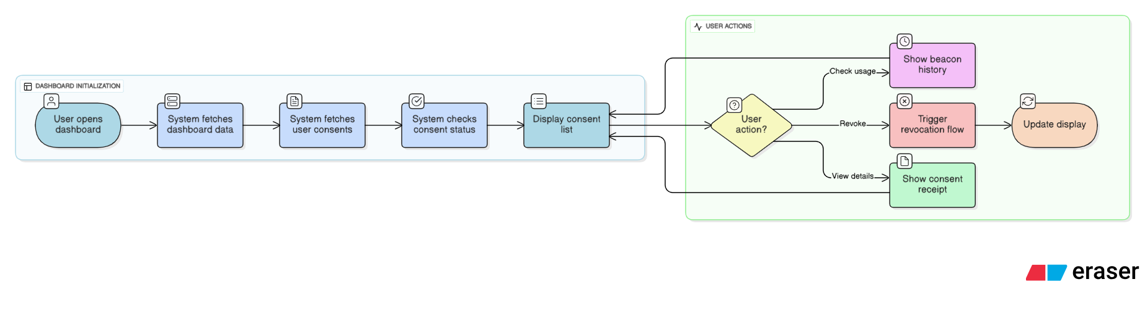

Flow 6: Complete User Journey
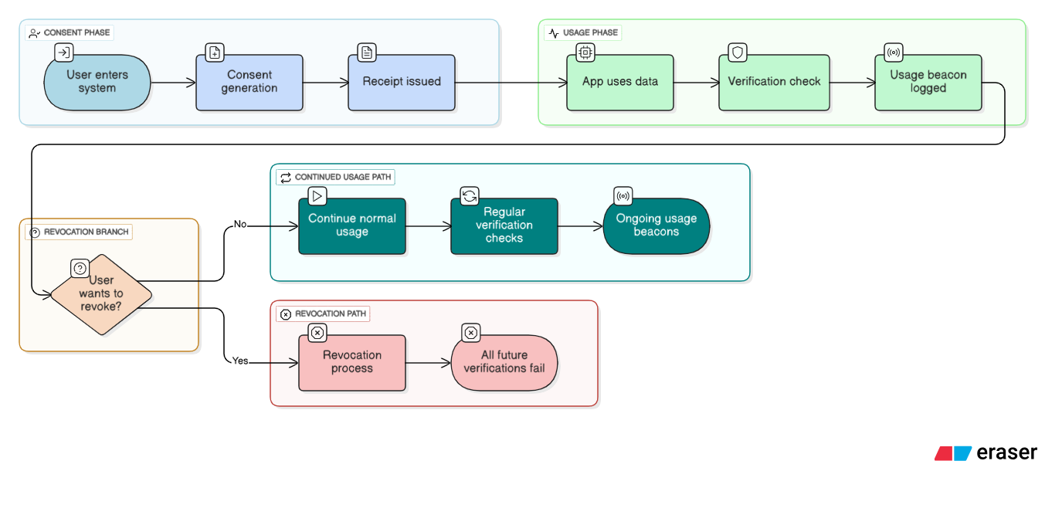
The flows cover:
- Consent Generation - User gives consent → system creates signed receipt
- Real-time Verification - App checks if consent is valid before using data
- Revocation Control - User cancels consent → all future verifications fail
- Usage Beaconing - App logs when/how data is used for audit trail
- Dashboard View - User interface to manage all consents
- Complete User Journey - End-to-end flow showing the full lifecycle

